EPERIMENT 2

Name : Aman sain

Sap lD: 500107367

Roll no: R2142220418

Aim : Working with Docker — Basic Commands

1. Finding a Redis Image on Docker Hub:

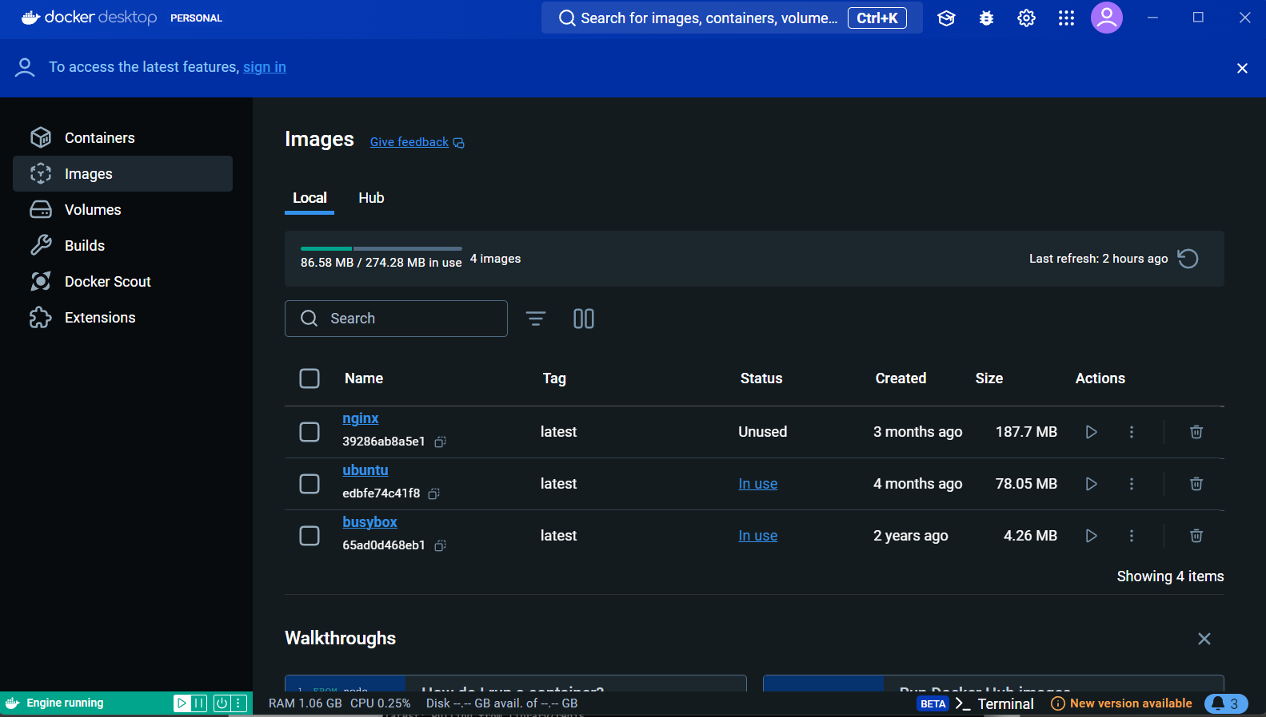
- Pulling redis image on local machine to use it offline docker pull redis

  - this command will pull the redis image from docker hub.
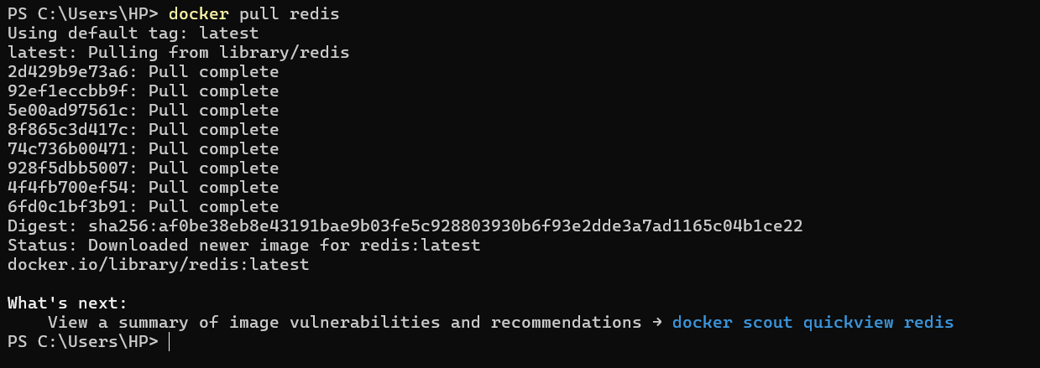
- Run Docker Container of Redis Image in background.

  - Command - docker run -d –name

- Run Docker PS and Docker PS –a

  - Use of docker ps is to provide a list of Docker containers on the machine. docker ps shows only running containers by default.

  - To view all containers -a flag is used with docker ps.

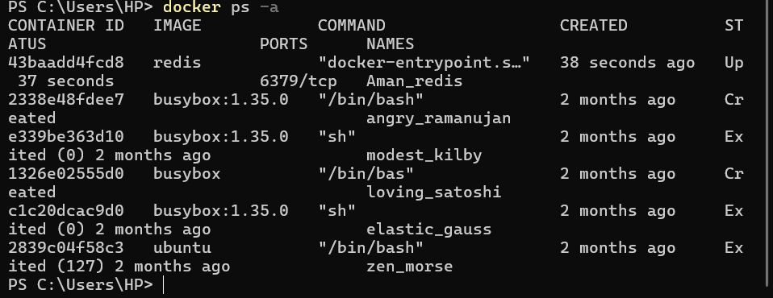

- Run Docker Container and take its console

  - To view running docker containers – use docker ps

  - To take its console i.e. enter inside container use docker exec –it <container_name/ID> /bin/bash
  - To exit the console use command – exit
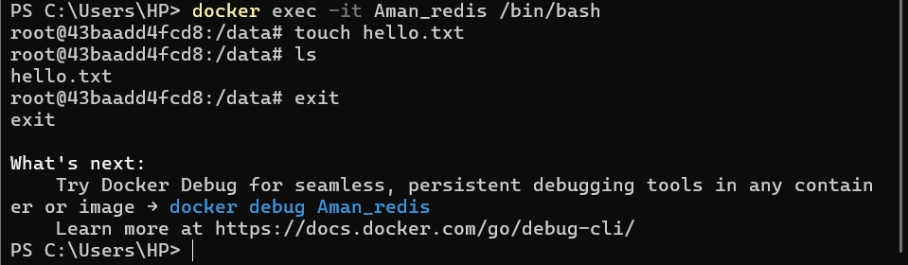

6. Create a Docker Volume and connect it

- To create volume use – docker volume create <volume_name>

